How to setup Jenkin server in our AWS ec2 instance
Jenkins- Is an Automated CI-CD tool, it is basically helps you to do the continuous integration and continuous deployment.
Steps
Login to AWS account – Sign in using root user
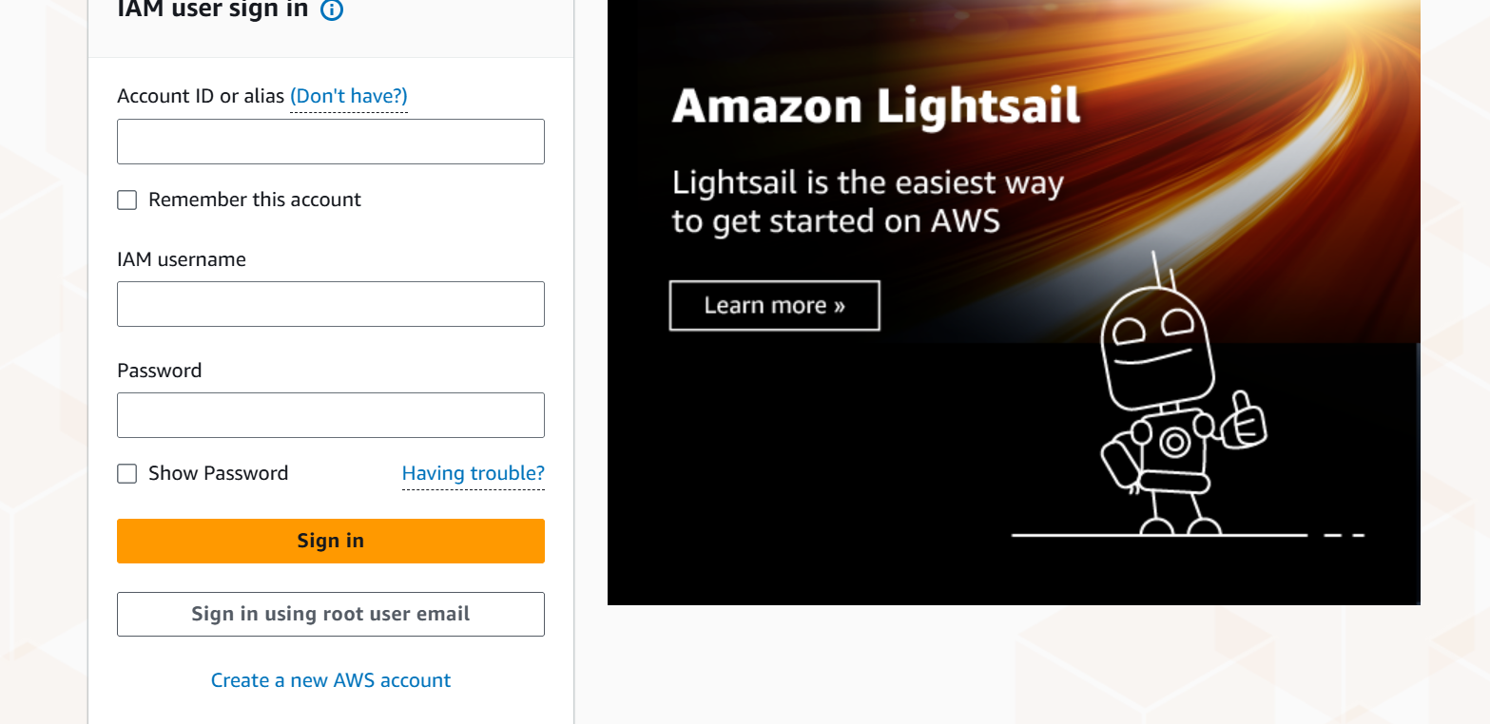
Click on Ec2 and launch an instance
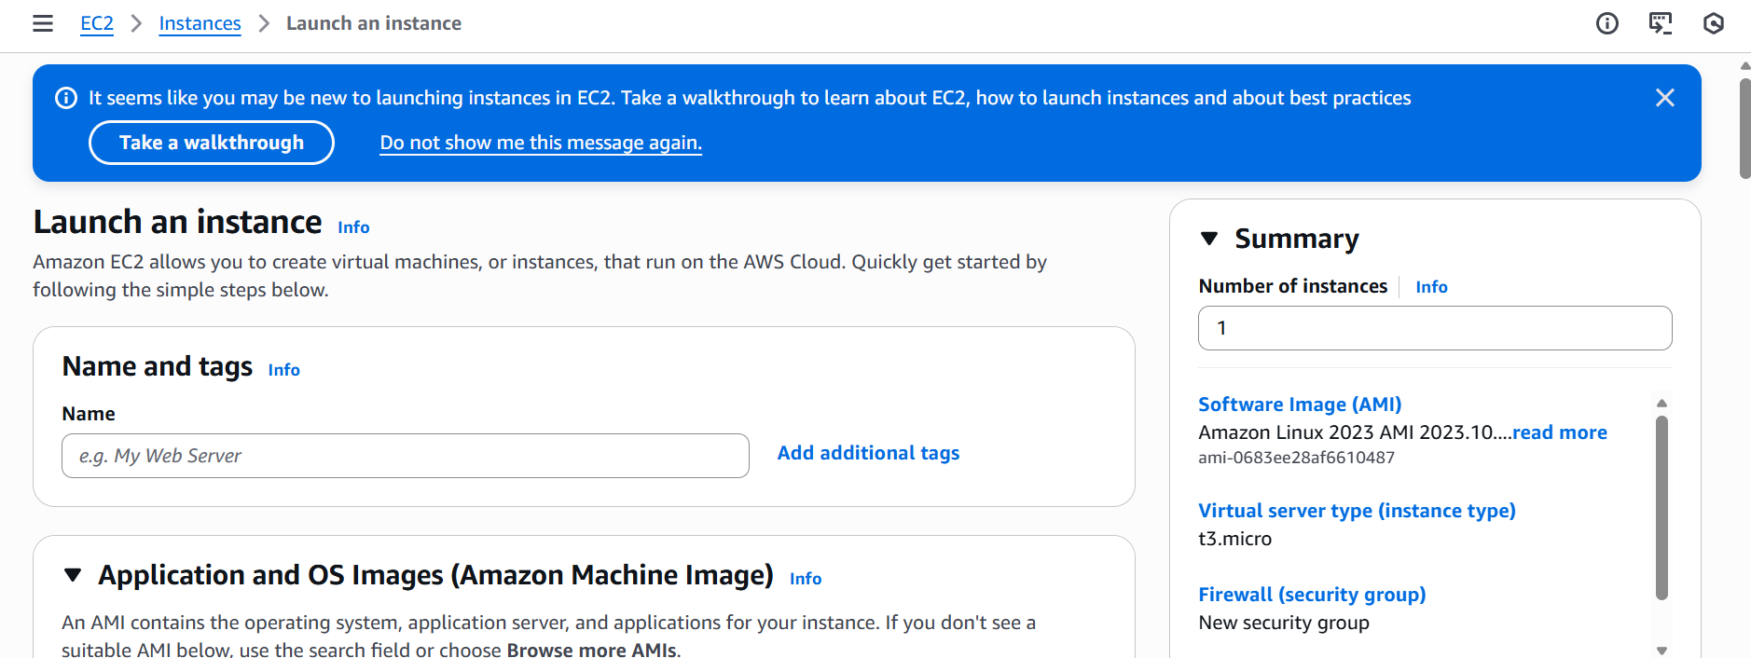

Provide name and Jenkin-Demo as shown in the below screen shot and select Ubuntu
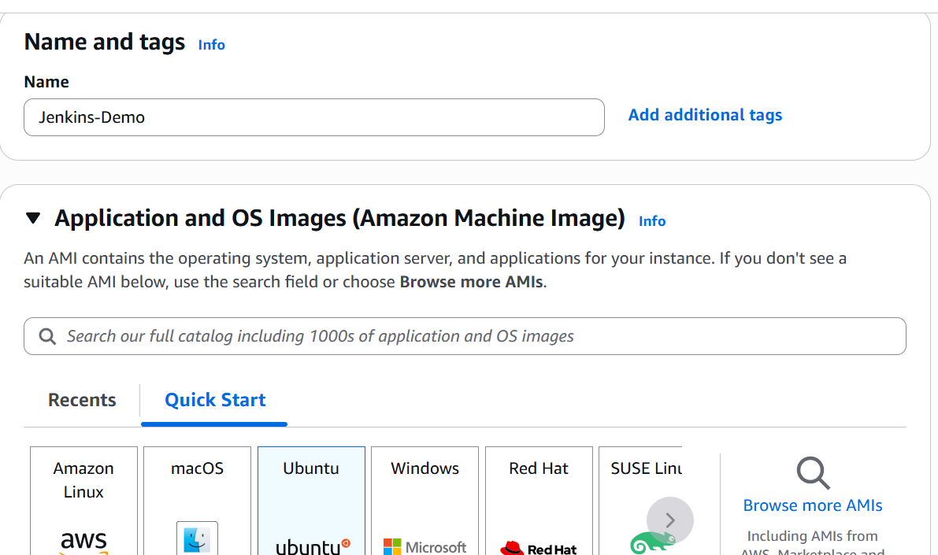

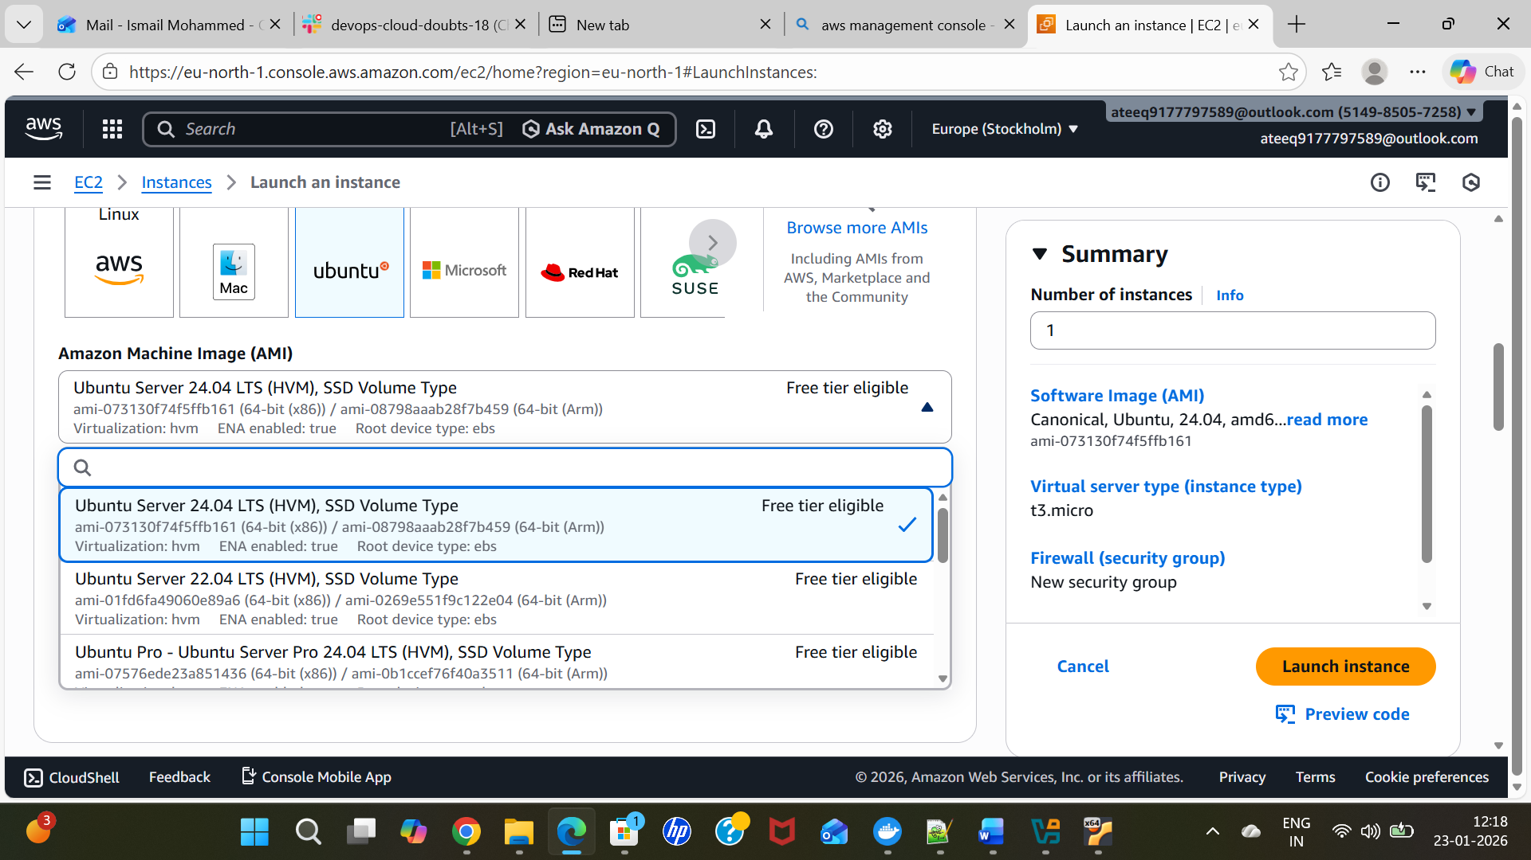
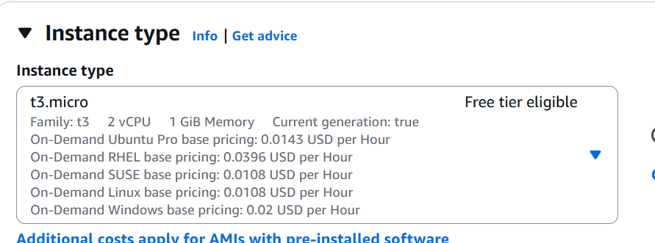
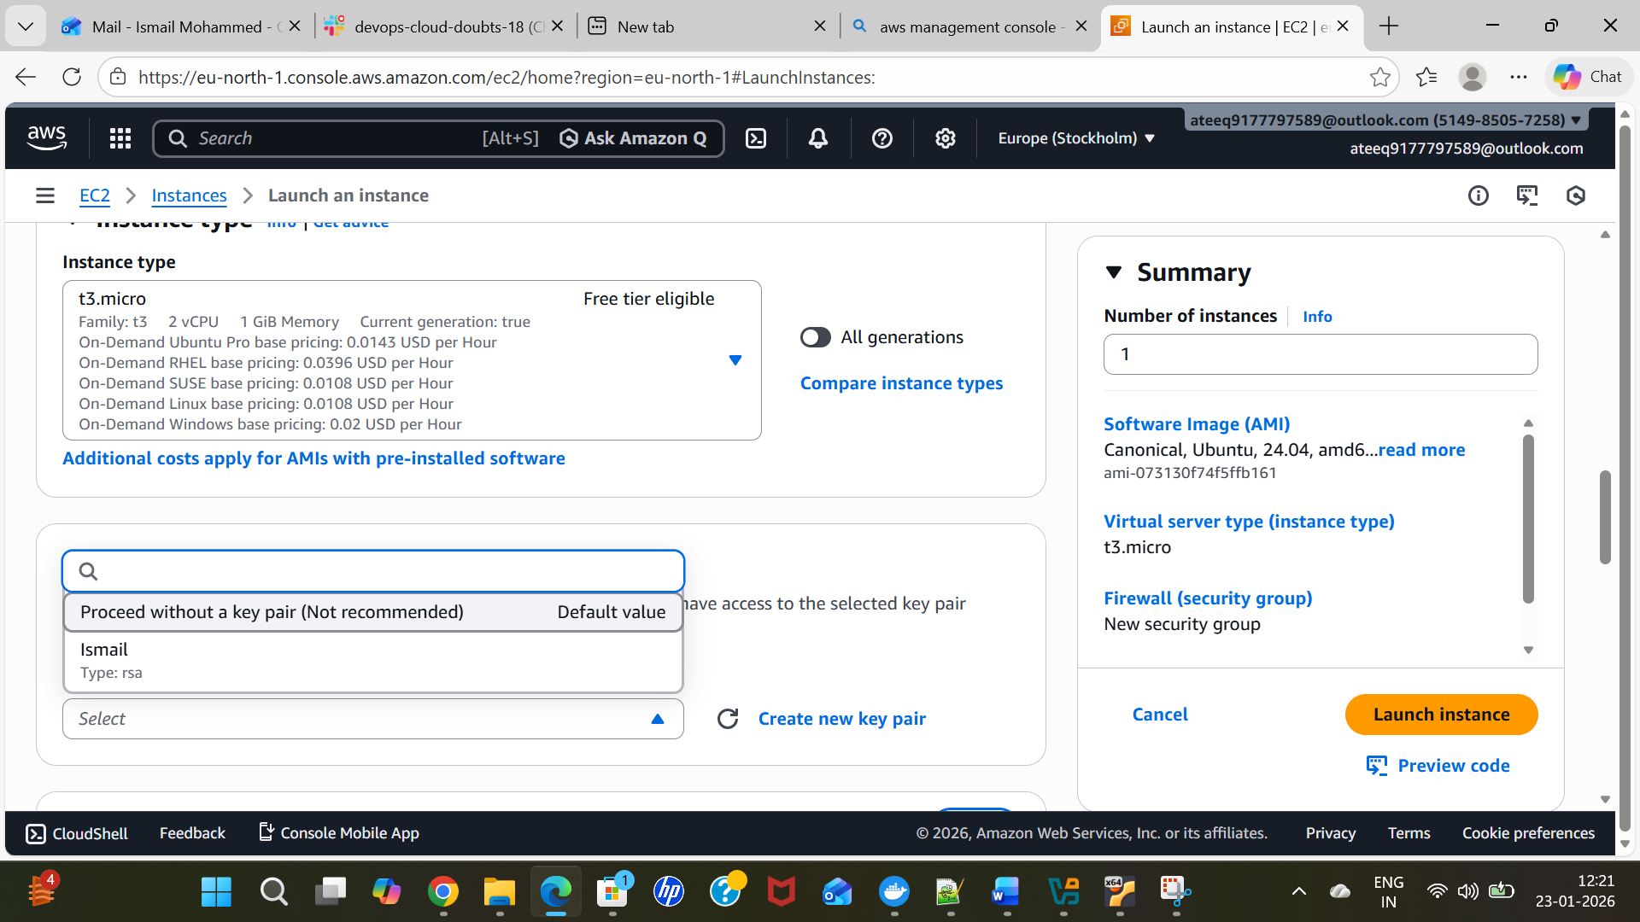
Tick mar Allow HTTPS Traffic from the internet, Allow HTTP Traffic from the internet

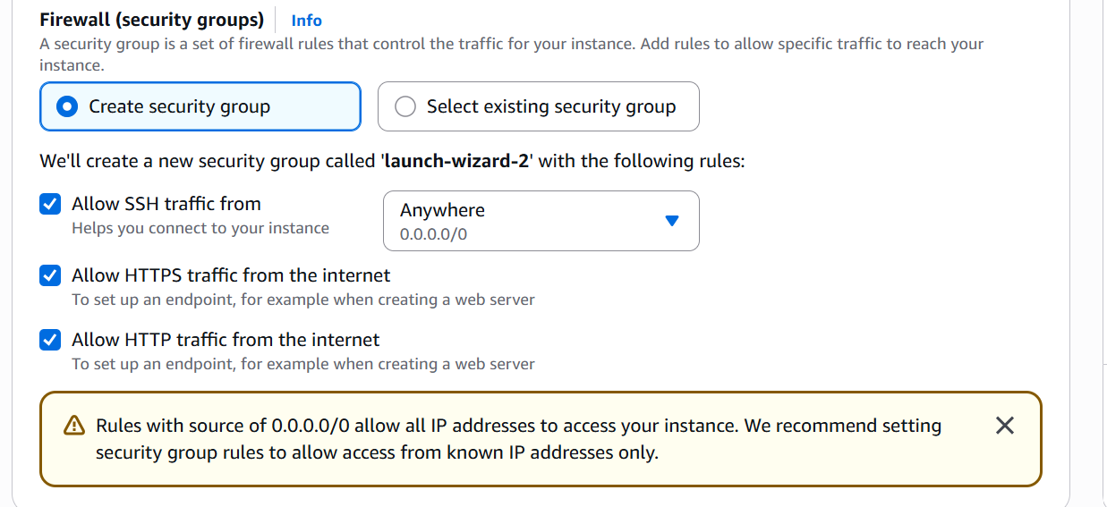
Click on Launch instance
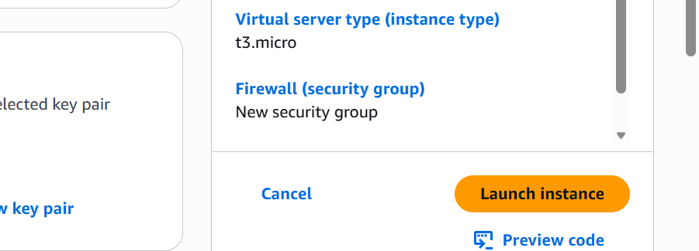
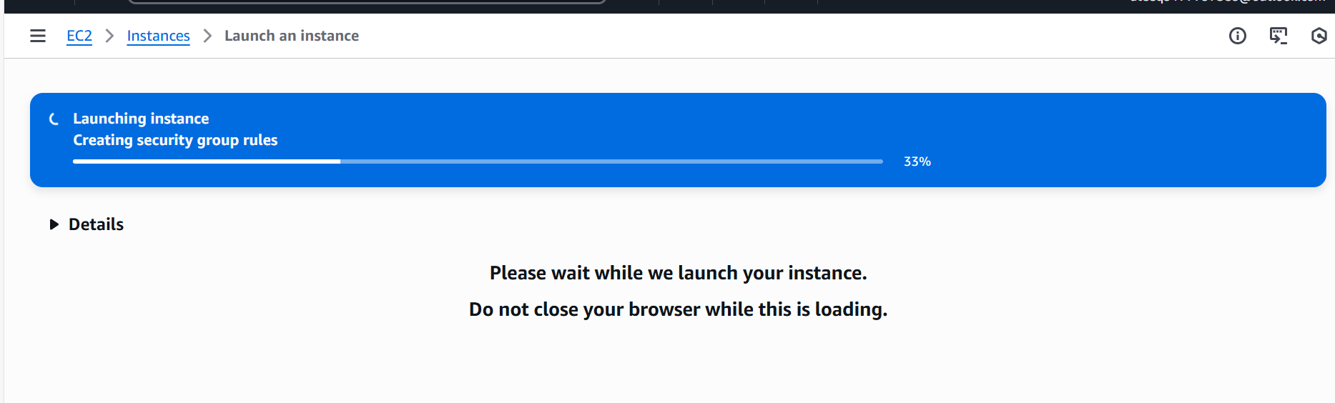
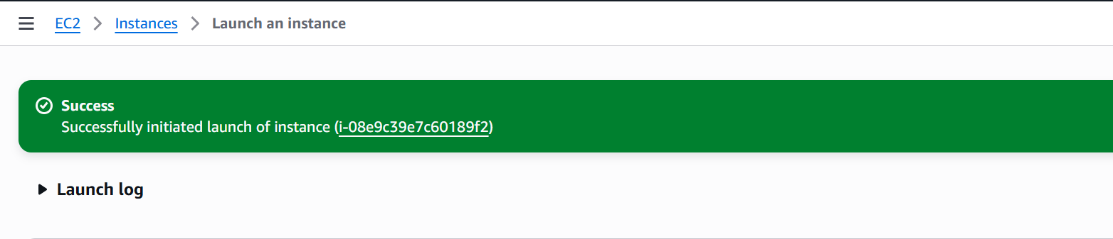
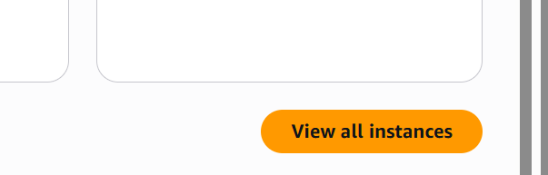
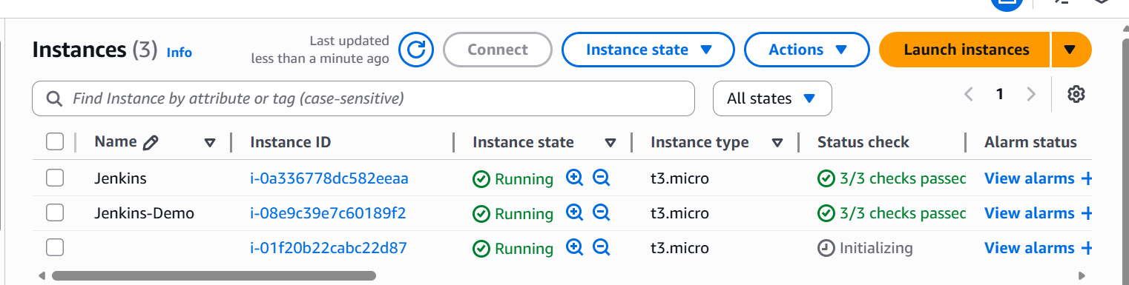

Click Connect post selecting instance name
Click on connect on the end of the web page.

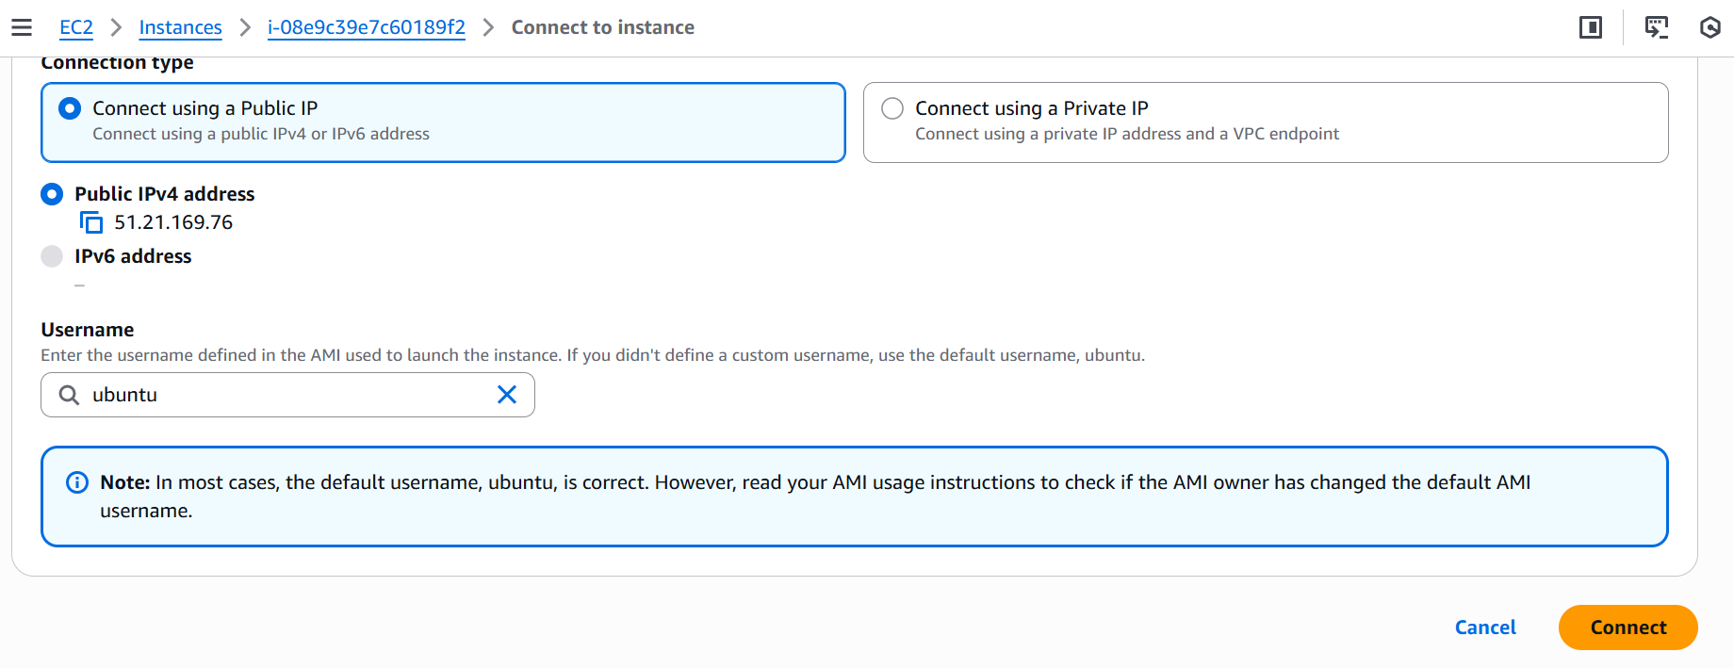
I will be getting my Terminal
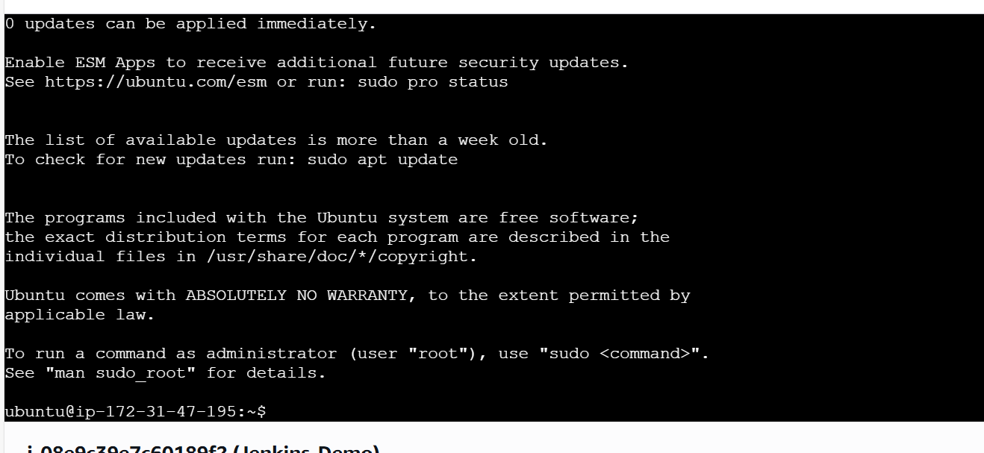
JAVA setup required to run the Jenkins
To install Java in Ubuntu machine
Command to install java - sudo apt install openjdk-8-jdk -y
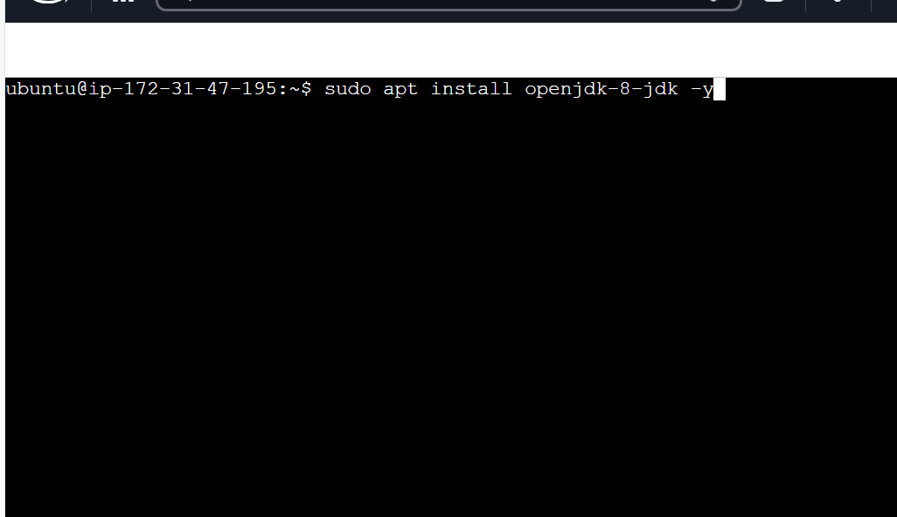

From browser goto the below url
pkg jenkins io
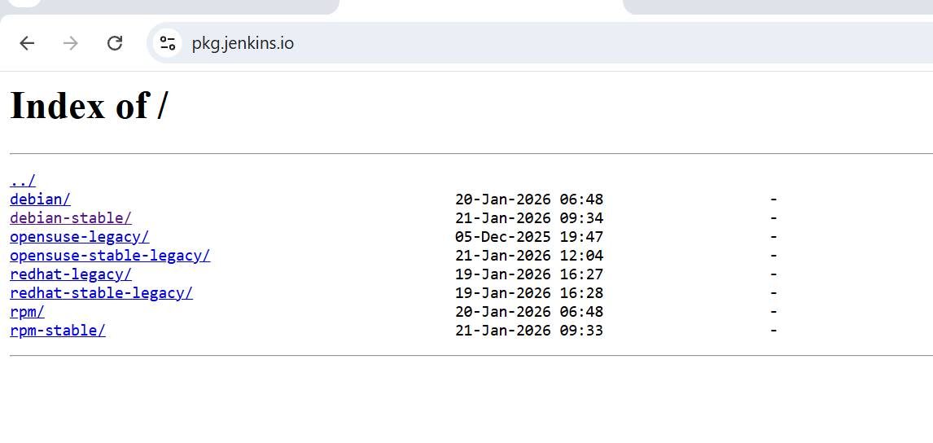
Select Debian-stable
Commands to install
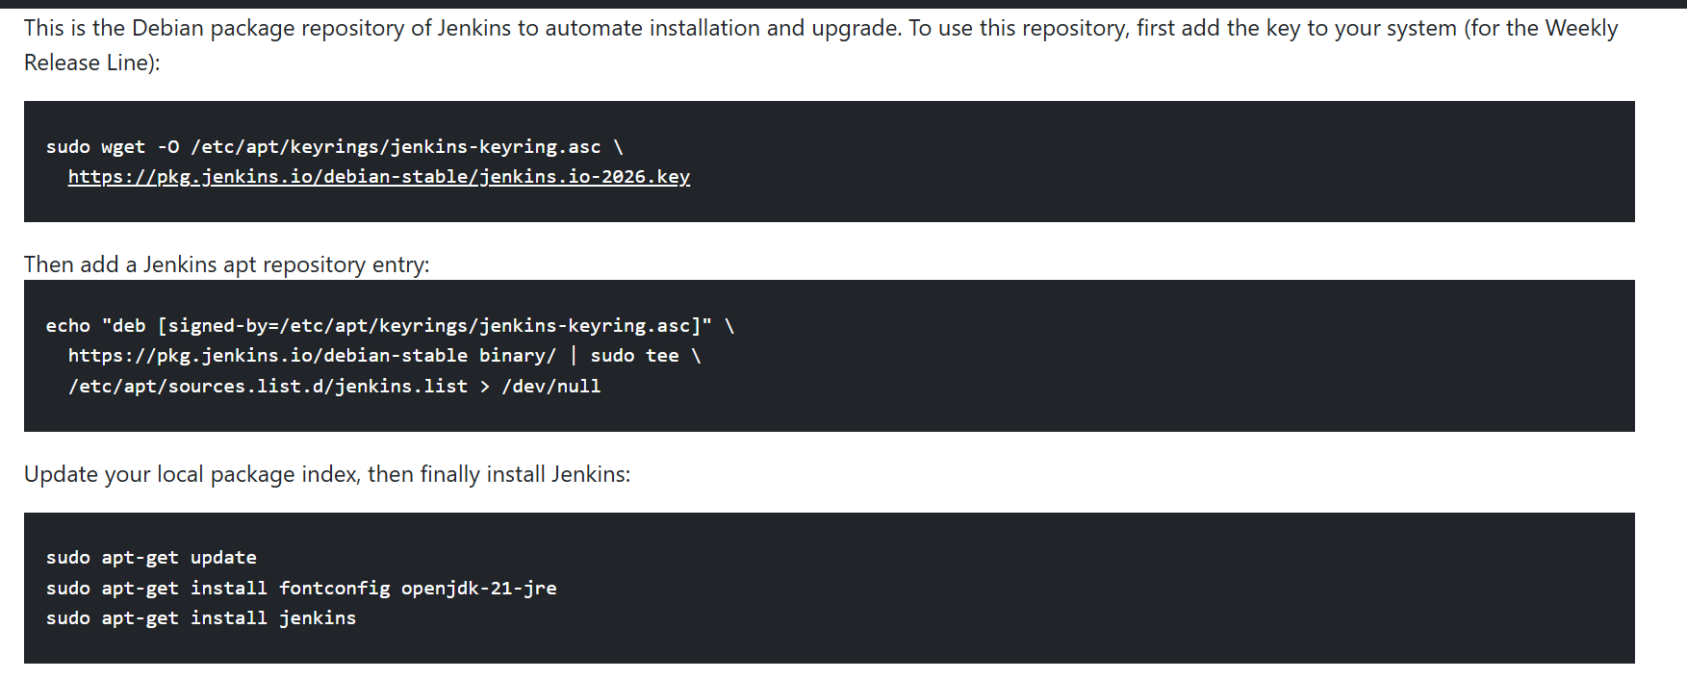
$ sudo systemctl start Jenkins -> To start the jenkins
$ sudo systemctl enable Jenkins -> To Enable the Jenkins
$ sudo systemctl status Jenkins -> To check the status

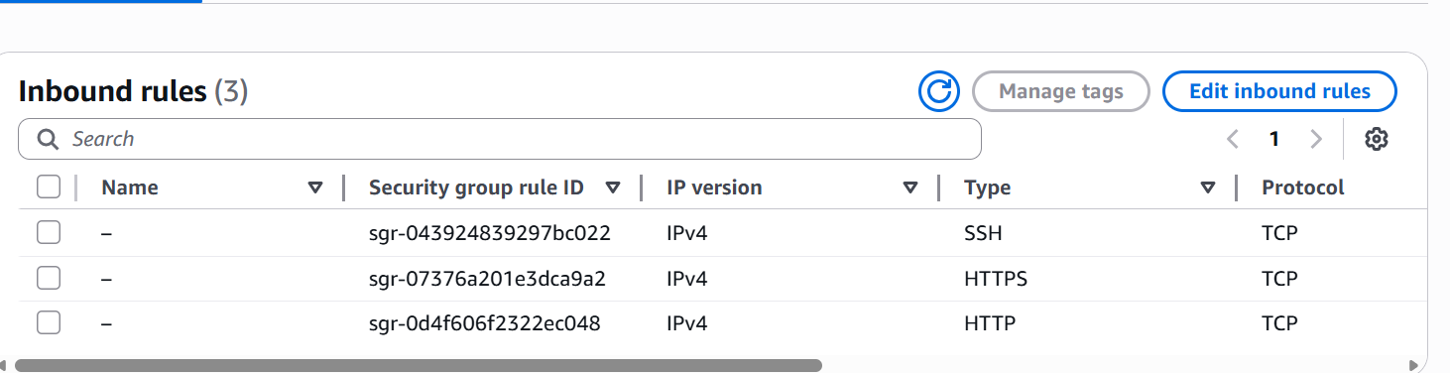

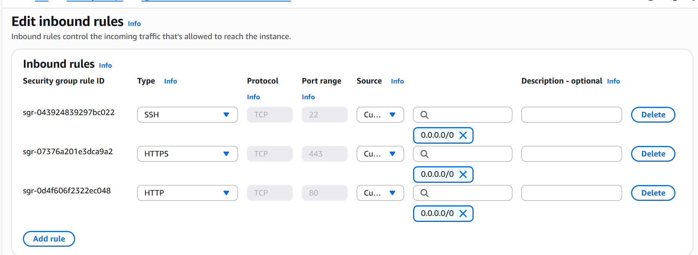

Click on add rule

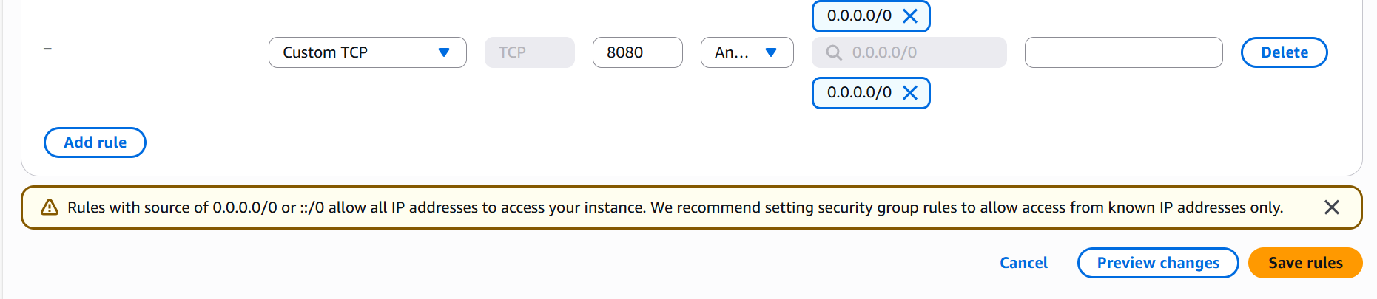
Click on save rule after selecting custom TCP and port 8080 ip ranges as shown in the above diagram.
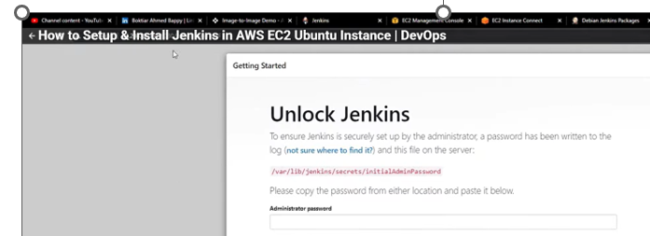

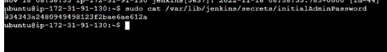

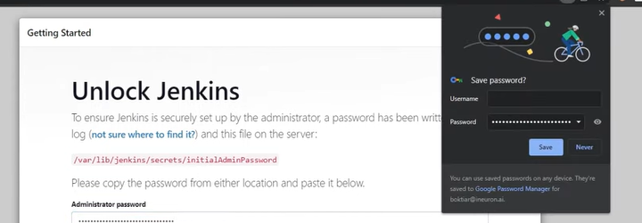

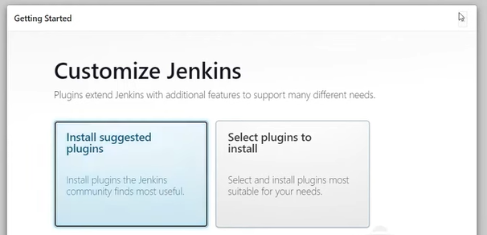
Click on install suggested plugins

